**Distributions Related to Normal Distributions**

Table of Contents

Normal Distribution 3

Chi-Square Distribution 4

-Distribution 6

-Distribution 8

We will be covering a few distributions related to inferential statistics now. These distributions are a little different from what we have covered before, since there are no equations we can use to find probabilities. Instead, we will have to use tables, like we did for normal distributions.

## Normal Distribution

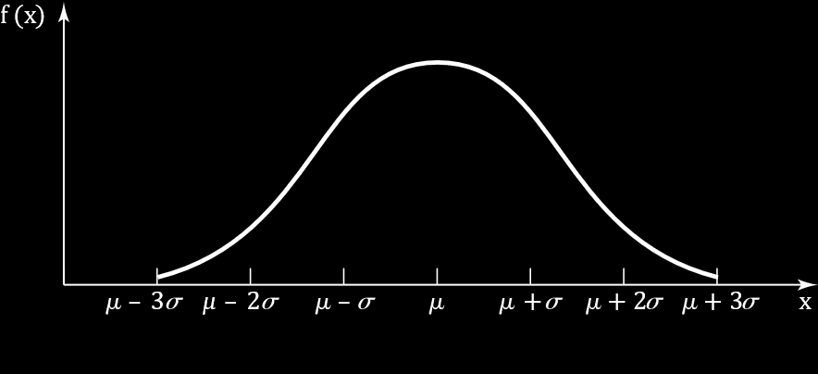

A random variable $X$ is said to be normally distributed if it has a perfectly bell-shaped curve. We describe such a distribution as $X\sim N\left(μ, σ^{2}\right)$, where $μ$ is the mean and $σ^{2}$ is the variance.

Here, we used the symbol $\sim$ to mean that $X$ is ‘distributed as’. We will also encounter another symbol, $\dot{\sim }$, which means ‘approximately distributed as’.

We also learnt about standard normal random variables, $Z\sim \left(0, 1\right)$ where $μ=0$ and $σ^{2}=1$. A normal random variable can be standardized using the formula

$$Z=\frac{X-μ}{σ}$$

Normal random variables and standard normal random variables will be heavily used in the rest of this course.

## Chi-Square Distribution

Let there be $n$ independent standard normal random variables, $Z_{1},…,Z_{n}$. Thus,

$Z_{i}\sim N\left(0, 1\right)$ $i=1,…,n$

A Chi-Square random variable, $K$, is then defined as

$$K=Z_{1}^{2}+Z_{2}^{2}+…+Z_{n}^{2}$$

$K$ has $n$ degrees of freedom, since we can freely choose $n$ standard normal random variables here. The degrees of freedom is important, since the tables we will use will provide values for specific degrees of freedom.

The distribution of $K$ is described as $K\sim χ_{n}^{2}$.

The curve for a chi-square random variable looks like this:

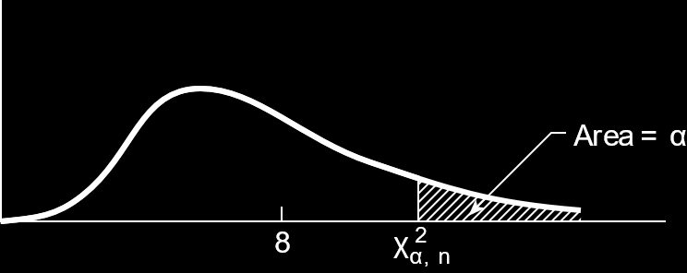

This graph is for $n=8$. Notice how the tail is longer than is present in a standard normal distribution. We will be learning how to calculate the area covered by $α$ later on.

Chi-square random variables are related to gamma random variables. If we have a random variable $X\sim gamma\left(\frac{n}{2},\frac{1}{2}\right)$, i.e. $α=\frac{n}{2}$ and $β=\frac{1}{2}$, this would be the same as a chi-square random variable with $n$ degrees of freedom. Thus, we can have a formula for CDF:

$$f_{K}\left(k\right)=\frac{\frac{1}{2}e^{-\frac{k}{2}}{\left(\frac{k}{2}\right)}^{\frac{n}{2}-1}}{Γ\left(\frac{n}{2}\right)}$$

However, we do not need this equation, since we cannot use it. A closed form solution does not exist for chi-square random variables. We will have to rely on tables.

## $t$-Distribution

A $t$-distribution is defined by two random variables, a standard normal random variable, $Z\sim N\left(0, 1\right)$, and a chi-square random variable, $K\sim χ_{n}^{2}$.

A $t$-distribution with $n$ degrees of freedom can be found as

$$T_{n}=\frac{Z}{\sqrt{\frac{K}{n}}}=\frac{Z}{\sqrt{\frac{1}{n}χ_{n}^{2}}}$$

As we increase the value of $n$, the height of the curve increases, and the height of the tail decreases.

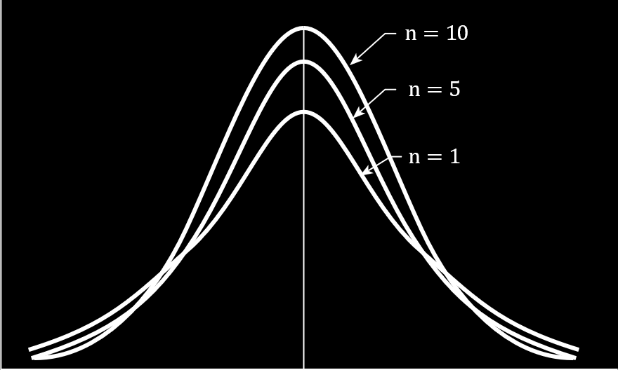

The only difference between the curve for a $t$-distribution and that for a standard normal distribution is that this curve has a thicker tail (it does not touch the axis), meaning there are more probabilities under the tail.

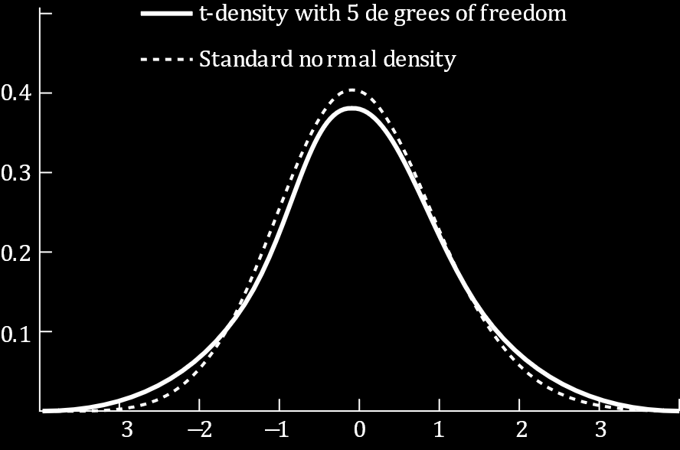

As such, it is important that we learn when to use the standard normal distribution and when to use the $t$-distribution.

## $F$-Distribution

$F$-distributions are defined by two chi-square distributions. If $K_{1}\sim χ_{n}^{2}$ and $K_{2}\sim χ_{m}^{2}$,

$$F_{n,m}=\frac{K_{1}/n}{K_{2}/m}=\frac{χ_{n}^{2}}{χ_{m}^{2}}$$

The curve for this distribution is a little flatter than the curve for a standard normal distribution.

